Table 1.1 How many students are currently in quarantine?

 | Mean | Median | Minimum | Maximum
Entire sample | 97.93 | 9.00 | 0.00 | 1000.00

Table 1.2 How many students are currently in quarantine? Broken out by for public and private colleges

for public and private colleges | Mean | Median | Minimum | Maximum
Public | 158.50 | 13.50 | 0.00 | 1000.00
Private | 49.47 | 6.00 | 0.00 | 464.00

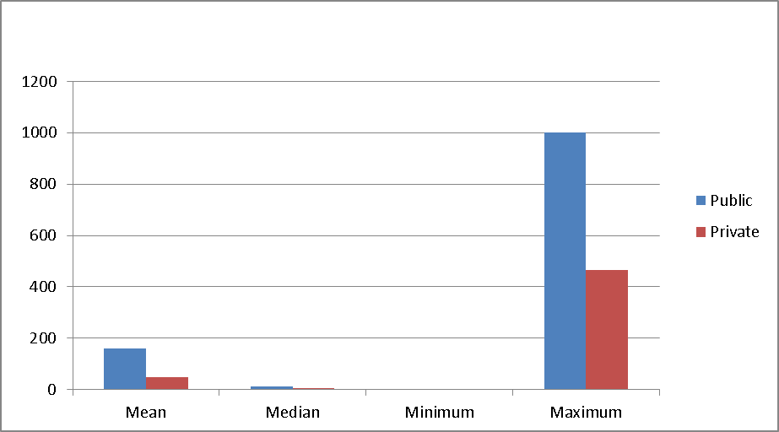
Number of Students in Quarantine
Broken out by public and private colleges

Table 1.3 How many students are currently in quarantine? Broken out by Title

Title | Mean | Median | Minimum | Maximum
Health Services Director | 66.27 | 9.00 | 0.00 | 464.00
Health Services Associate Director | 62.89 | 6.00 | 0.00 | 377.00
Nurse, Doctor, Counselor | 361.33 | 44.00 | 40.00 | 1000.00

Table 1.4 How many students are currently in quarantine? Broken out by type or Carnegie class

by type or Carnegie class | Mean | Median | Minimum | Maximum
Community College | 0.00 | 0.00 | 0.00 | 0.00
BA | 76.24 | 7.00 | 0.00 | 1000.00
MA/PHD | 131.25 | 26.50 | 8.00 | 464.00
Research University | 164.60 | 23.00 | 3.00 | 405.00

Table 1.5 How many students are currently in quarantine? Broken out by enrollment level

by enrollment level | Mean | Median | Minimum | Maximum
under 2000 | 13.14 | 4.00 | 0.00 | 75.00
2000-5000 | 25.11 | 9.00 | 0.00 | 97.00
5000+ to 15000 | 141.00 | 10.00 | 8.00 | 405.00
15000+ to 30000 | 148.00 | 17.50 | 3.00 | 464.00
More than 30000 | 507.50 | 507.50 | 15.00 | 1000.00

Table 1.6 How many students are currently in quarantine? Broken out by tuition level

by tuition level | Mean | Median | Minimum | Maximum
Under $7000 | 98.75 | 9.00 | 0.00 | 377.00
$7000 to $15000 | 10.33 | 10.00 | 9.00 | 12.00
$15000+ to $30000 | 305.60 | 75.00 | 8.00 | 1000.00
$30000+ to $50000 | 82.29 | 23.00 | 0.00 | 464.00
$50000+ | 14.25 | 2.50 | 0.00 | 97.00

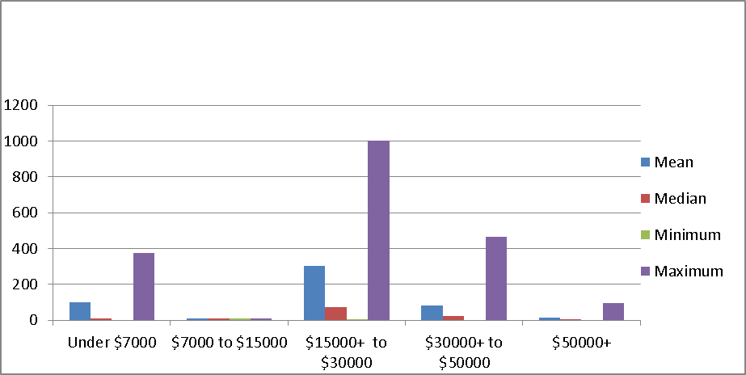
Number of Students in Quarantine
Broken out by tuition level

Table 1.7 How many students are currently in quarantine? Broken out by current college operating model

by current college operating model | Mean | Median | Minimum | Maximum
Completely or Nearly Completely Online | 16.57 | 6.00 | 0.00 | 75.00
Mostly Online | 134.00 | 12.50 | 0.00 | 1000.00
Mostly or Completely In-Person | 115.00 | 7.50 | 1.00 | 464.00

Table 1.8 How many students are currently in quarantine? Broken out by % of students living on campus

% of students living on campus | Mean | Median | Minimum | Maximum
5% or less | 12.43 | 6.00 | 0.00 | 40.00
5%+ to 15% | 68.00 | 9.50 | 0.00 | 377.00
15%+ to 30% | 490.67 | 464.00 | 8.00 | 1000.00
30%+ to 60% | 107.40 | 44.00 | 4.00 | 405.00
More than 60% | 23.33 | 5.50 | 1.00 | 97.00

